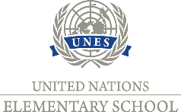Private Elementary School UNES, Javorová 12/644, Nitra

Dear parents,
I would like to inform you about current changes in the organization of the school.
Based on the current decision of the Government of the Slovak Republic, the condition of proving a negative result of the COVID-19 test for pupils and one legal representative of a pupil in the full-time form of education in schools is cancelled from April 29, 2021. This means that the testing of 5th - 7th grades pupils is cancelled. However, the obligation to fill in and send the declaration still applies from May 3, 2021, it is no longer necessary to enclose a copy of the negative test for COVID-19 or proof of exemption. Wearing masks for children is still mandatory.

If you have any questions, you can contact me: 0905 418 923
Sincerely,
Ing.Iveta Orolínová, school director

